Spring Security and oauth concepts:

Why spring Security?

* Login and log out functionality
* Allow/block access Urls to logged in users
* Allow/block access URLs to logged in users with certain roles

Spring Security Can Do:

* Username/password Authentication
* SSO/LDAP/OKTA
* App level Authorization
* Intra App Authorization like Oauth
* Tokens/JWT
* Method level Security

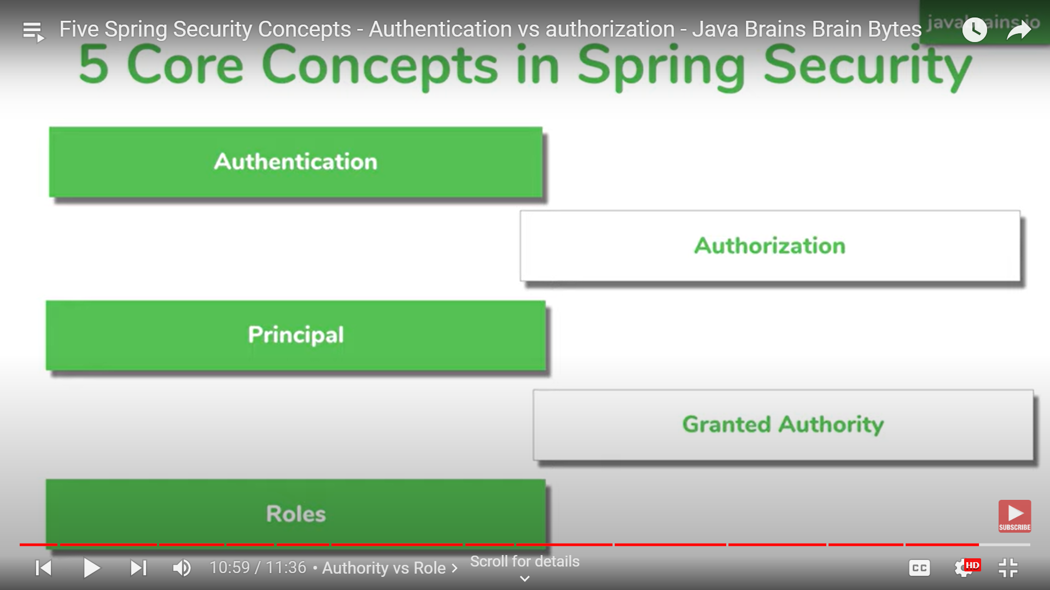

Authentication – who are you?

Authorization – what they can do?

Roles – Specific roles to access to resource.

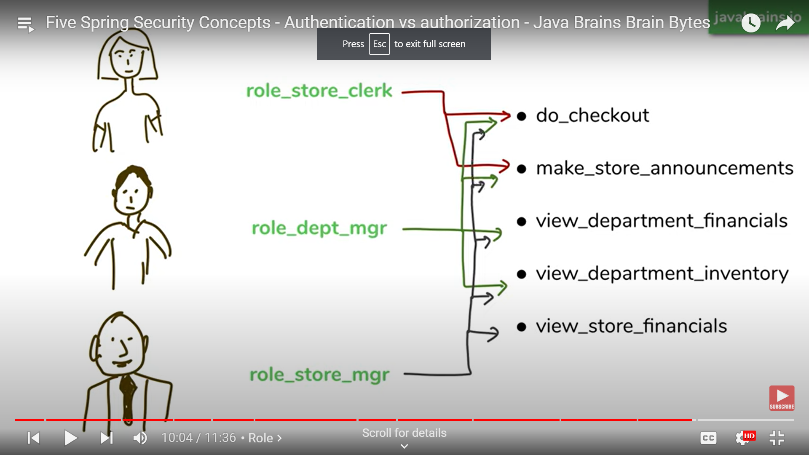

Filter:

Filter intercepts and decides which URL to access.

Provide manager checks which authentication mechanism to be used.

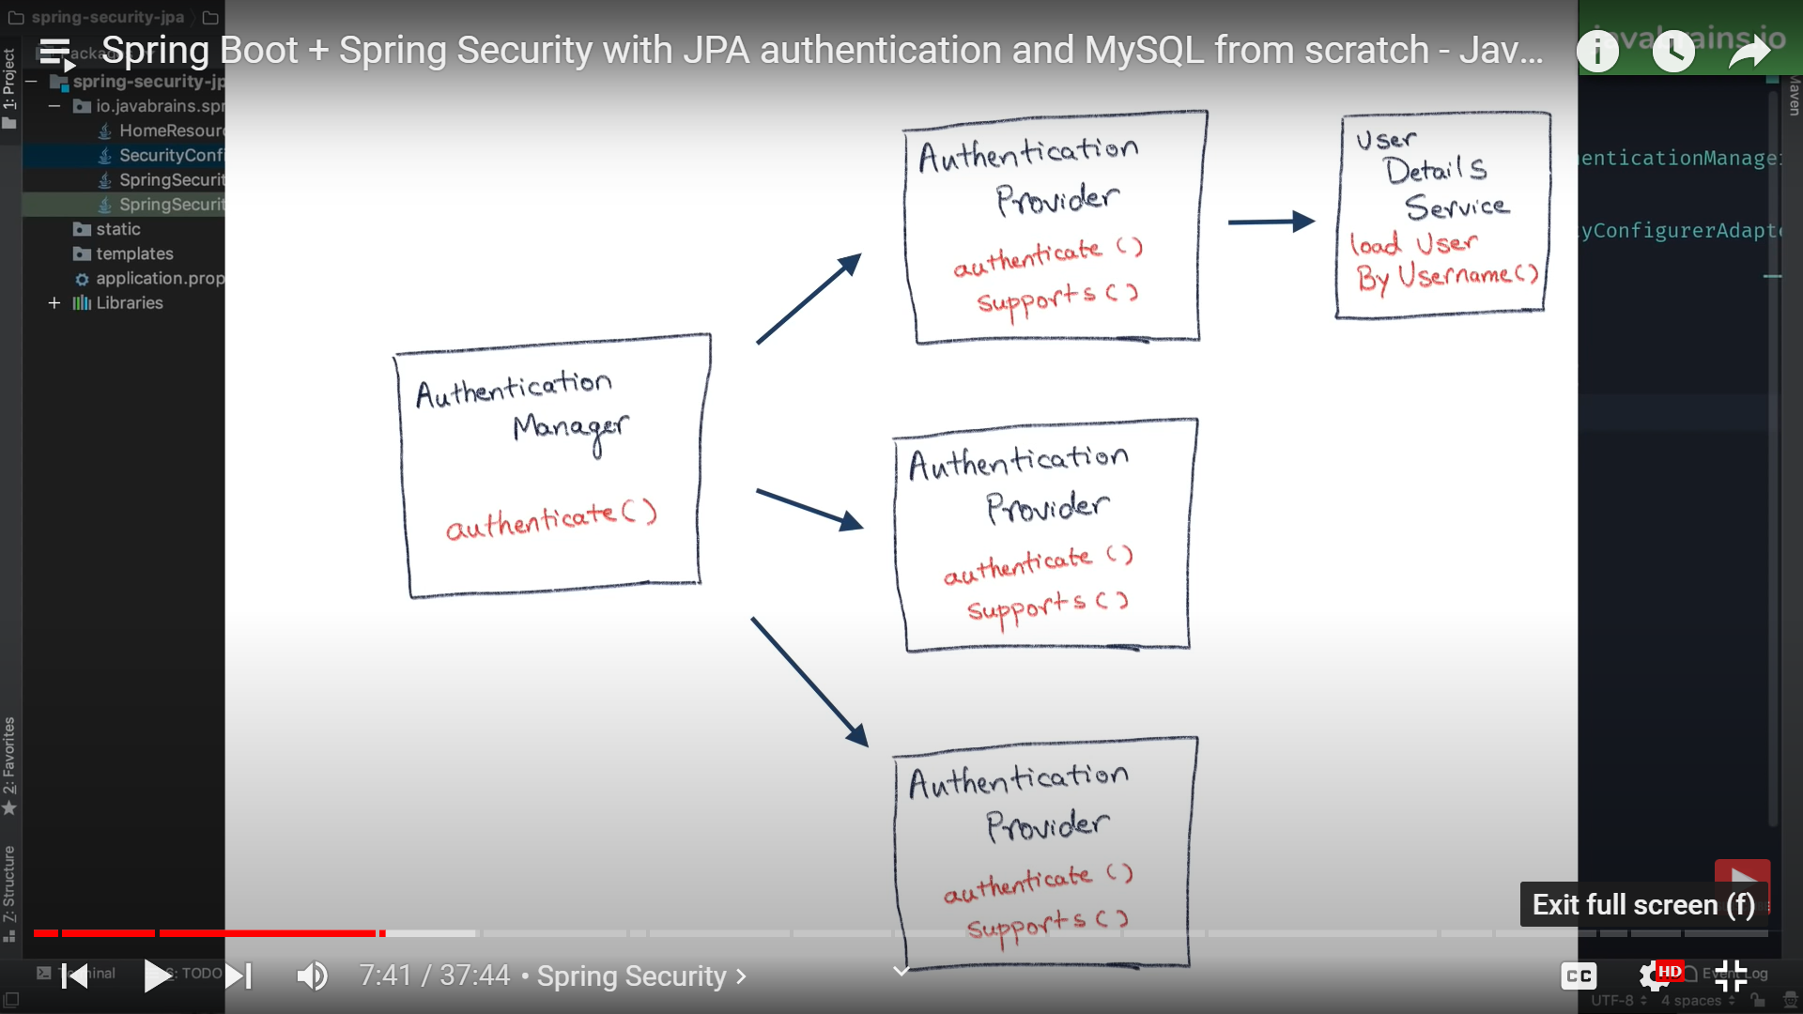

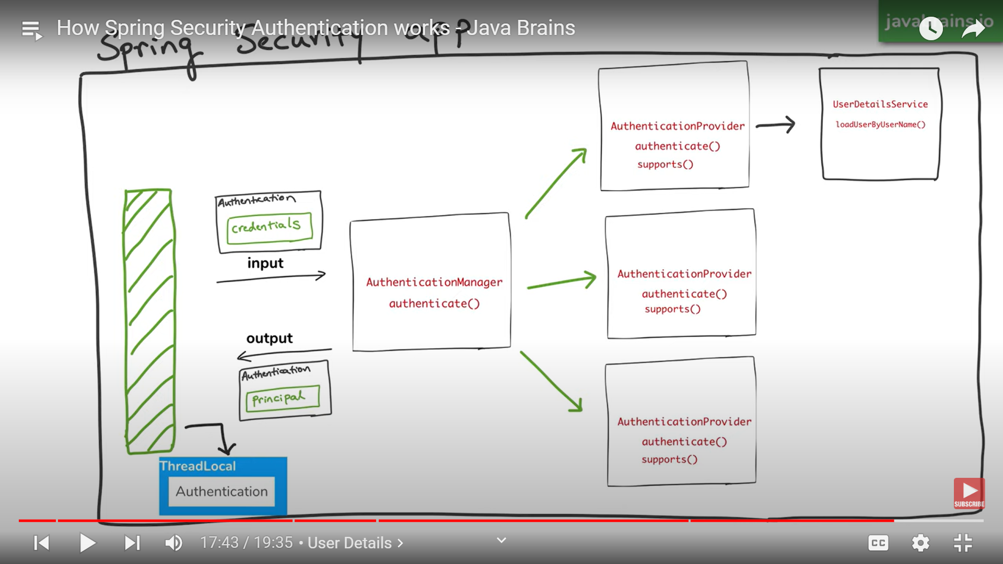

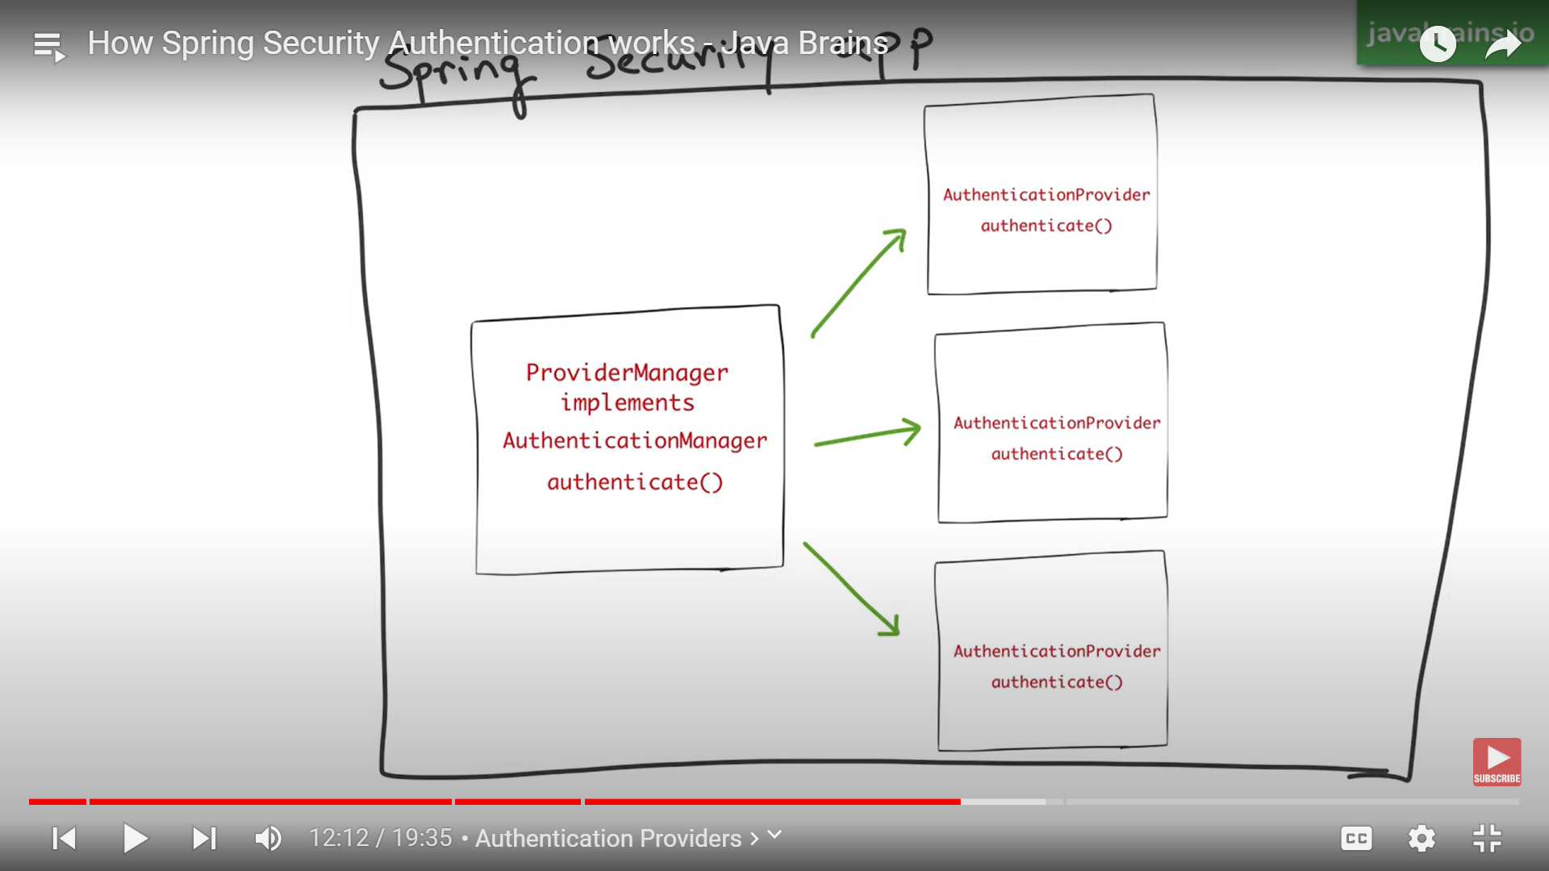

Spring Security JWT:

<https://www.bezkoder.com/spring-boot-jwt-authentication/>

Steps:

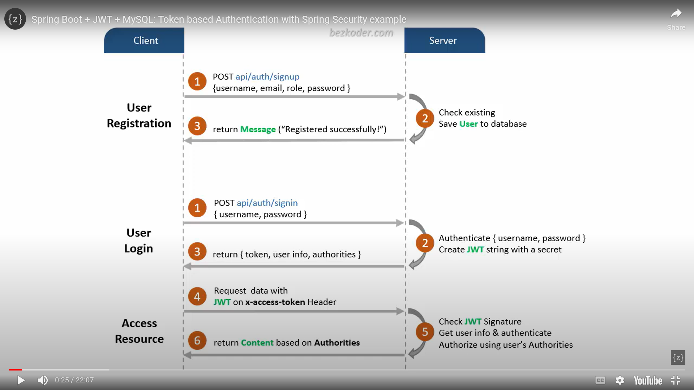

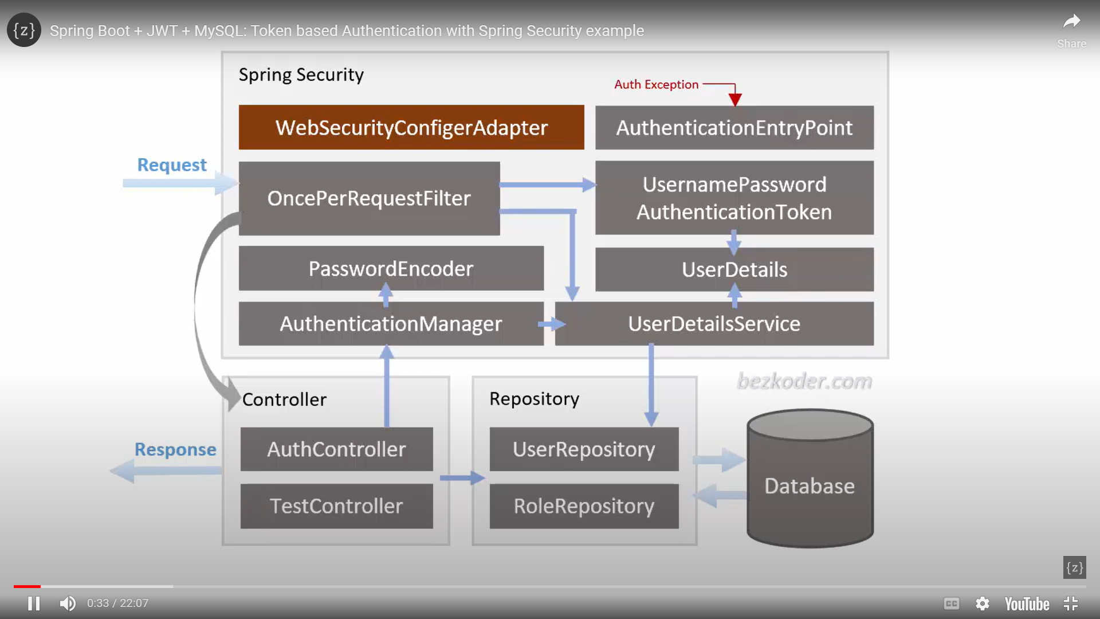

User sign up: create user details and fetch roles details(admin,user,Moderator..etc) and store user(including roles) into DB

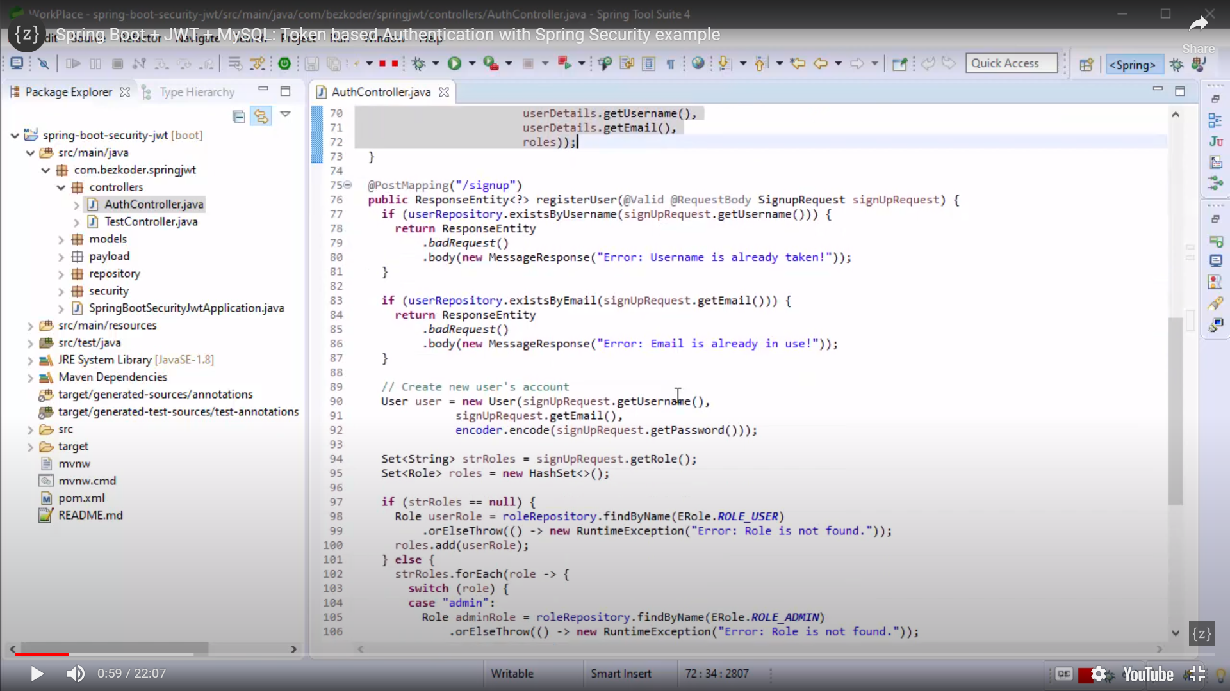

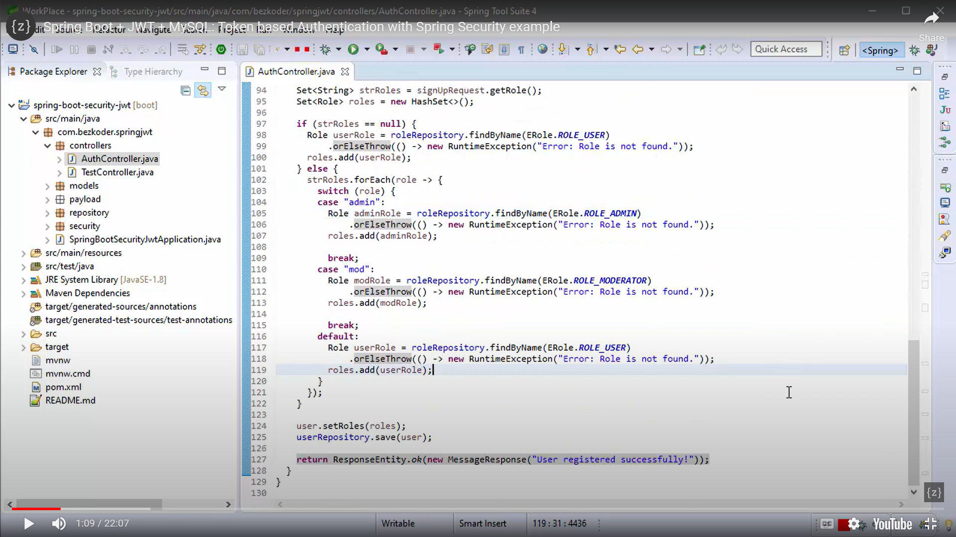

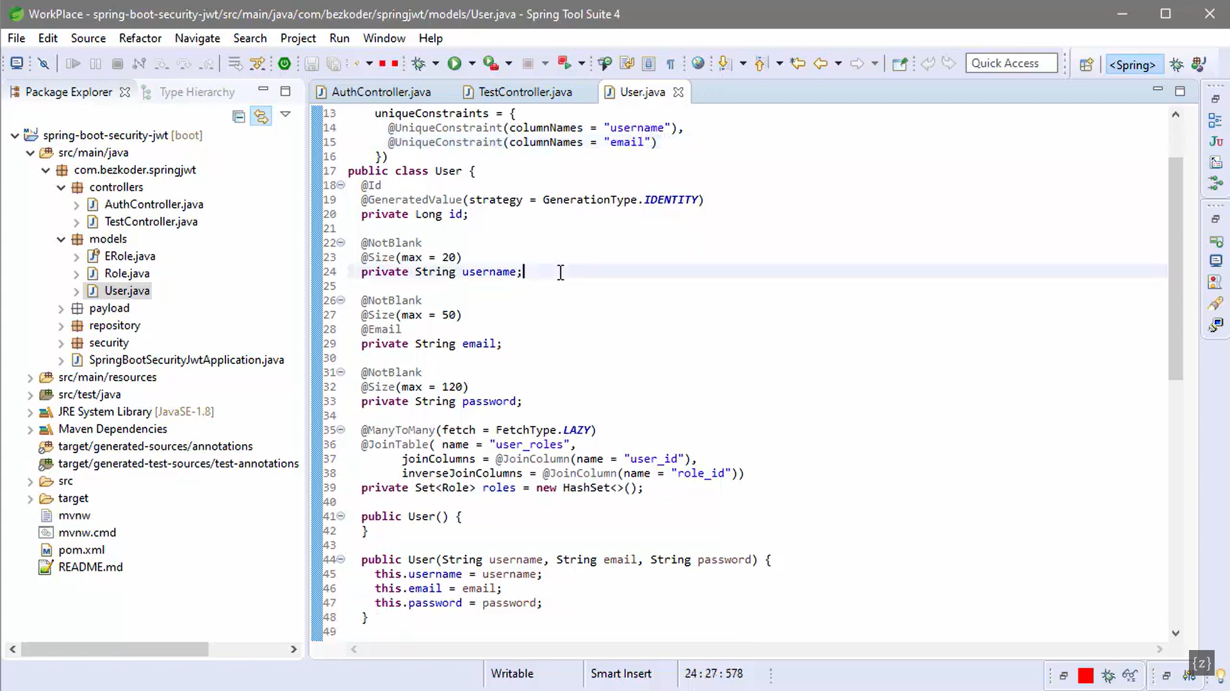

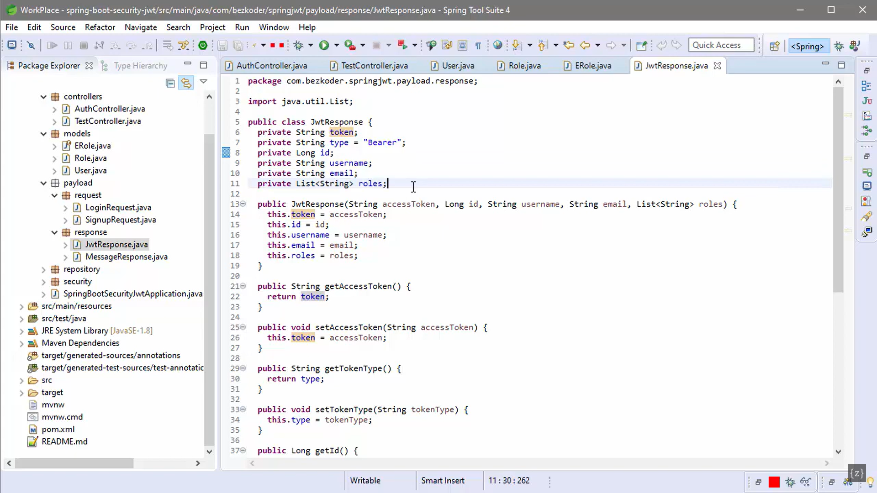

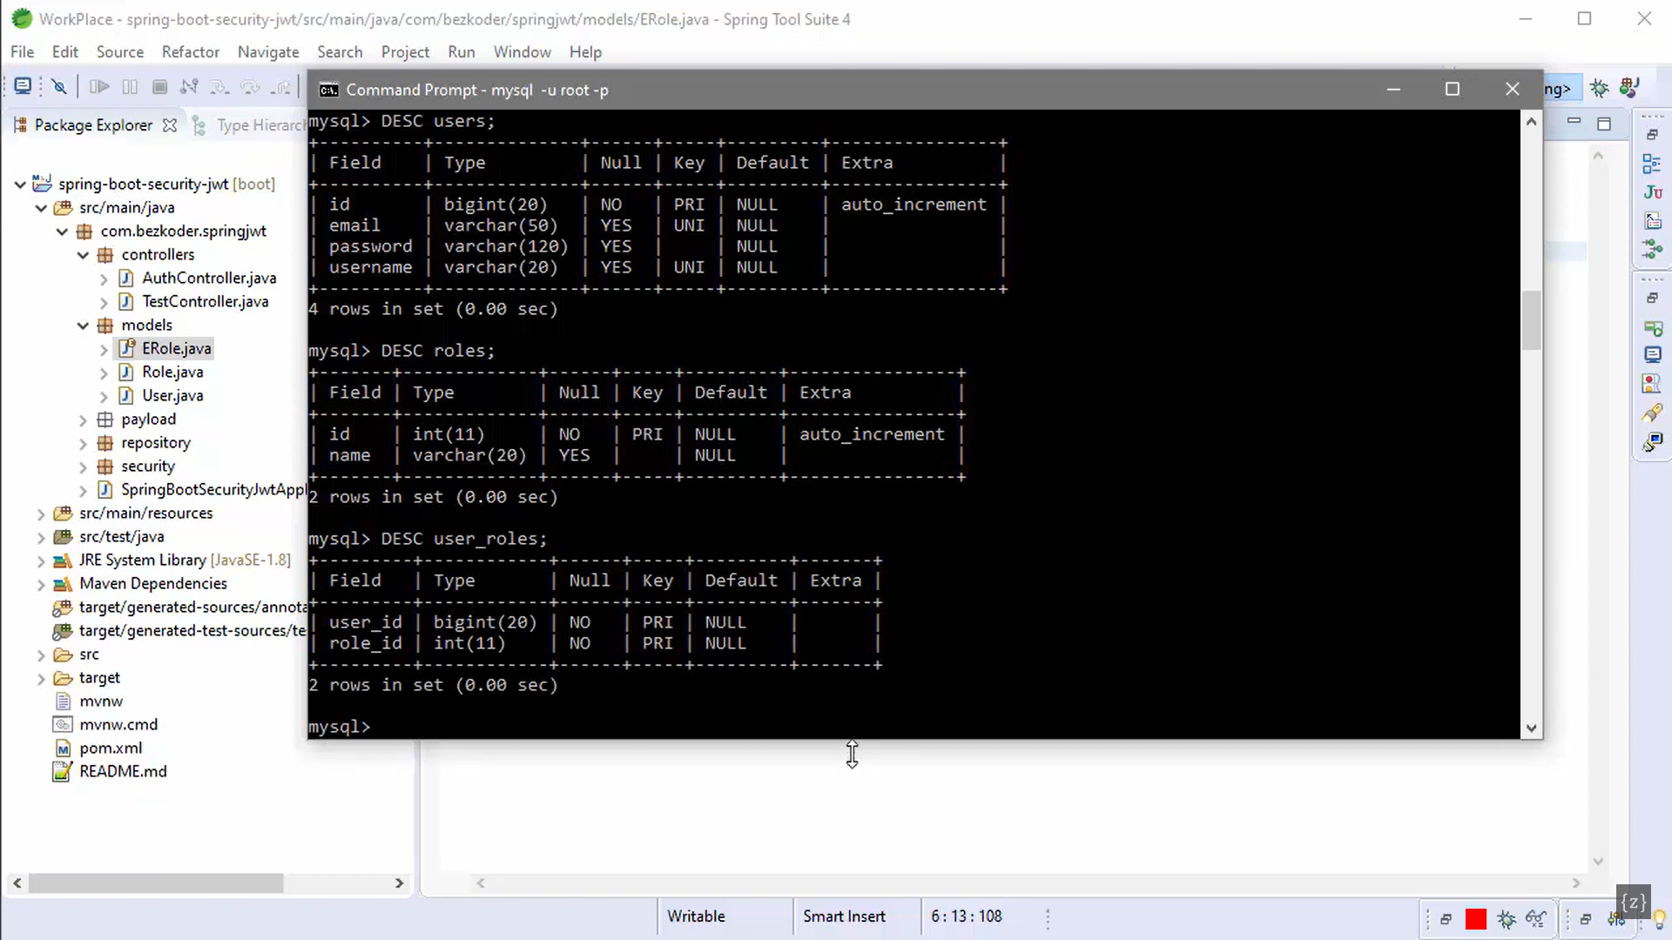

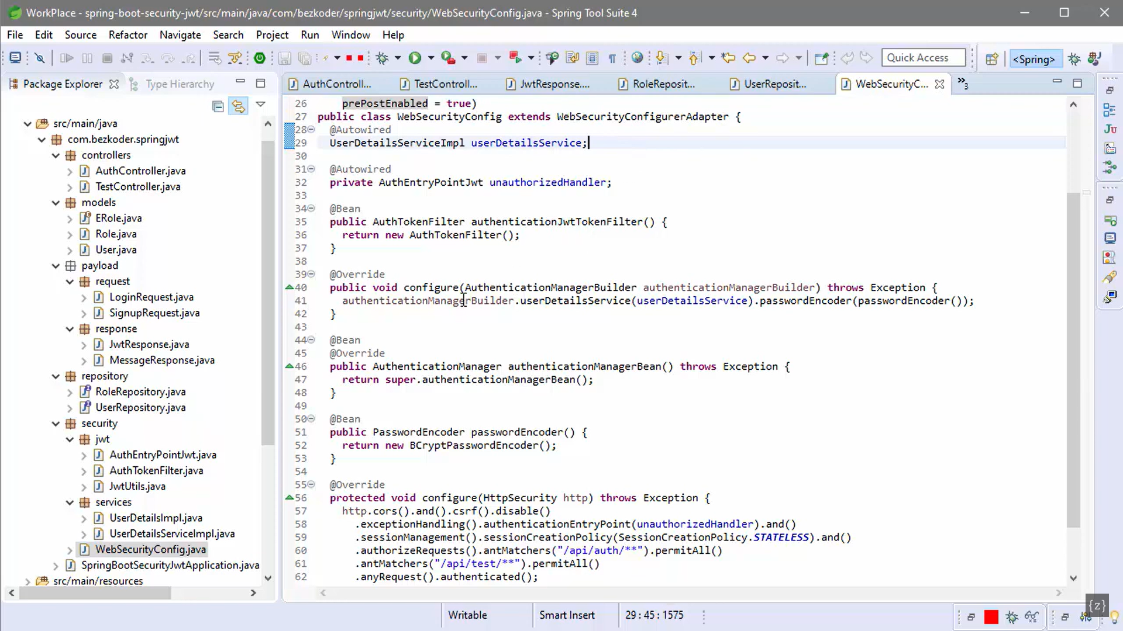

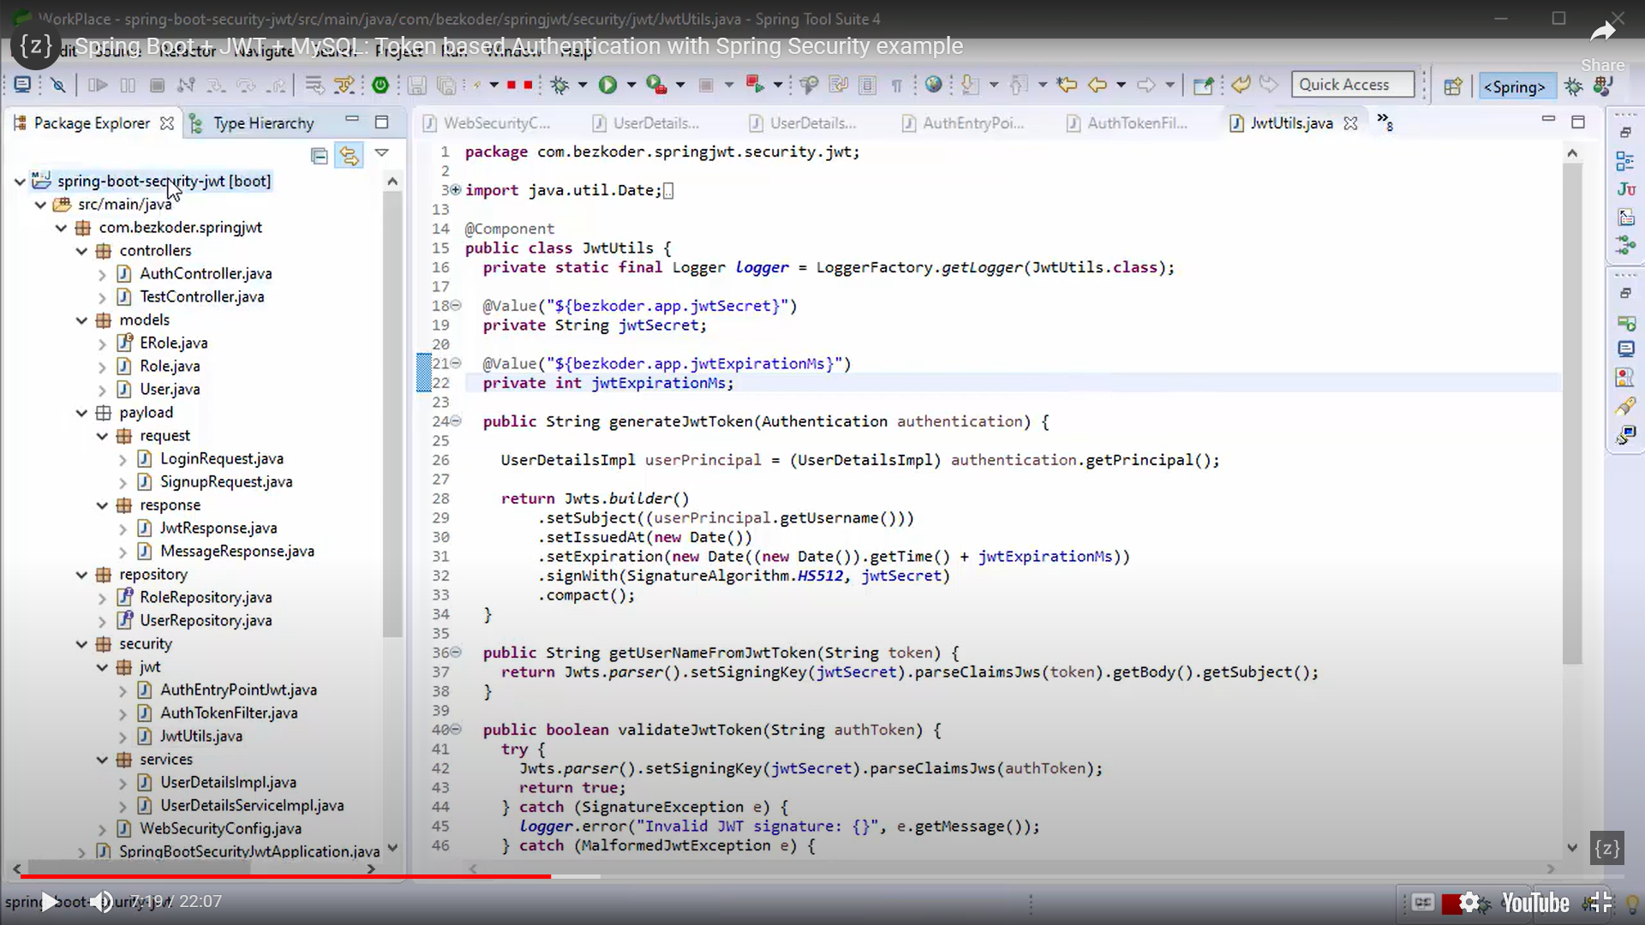

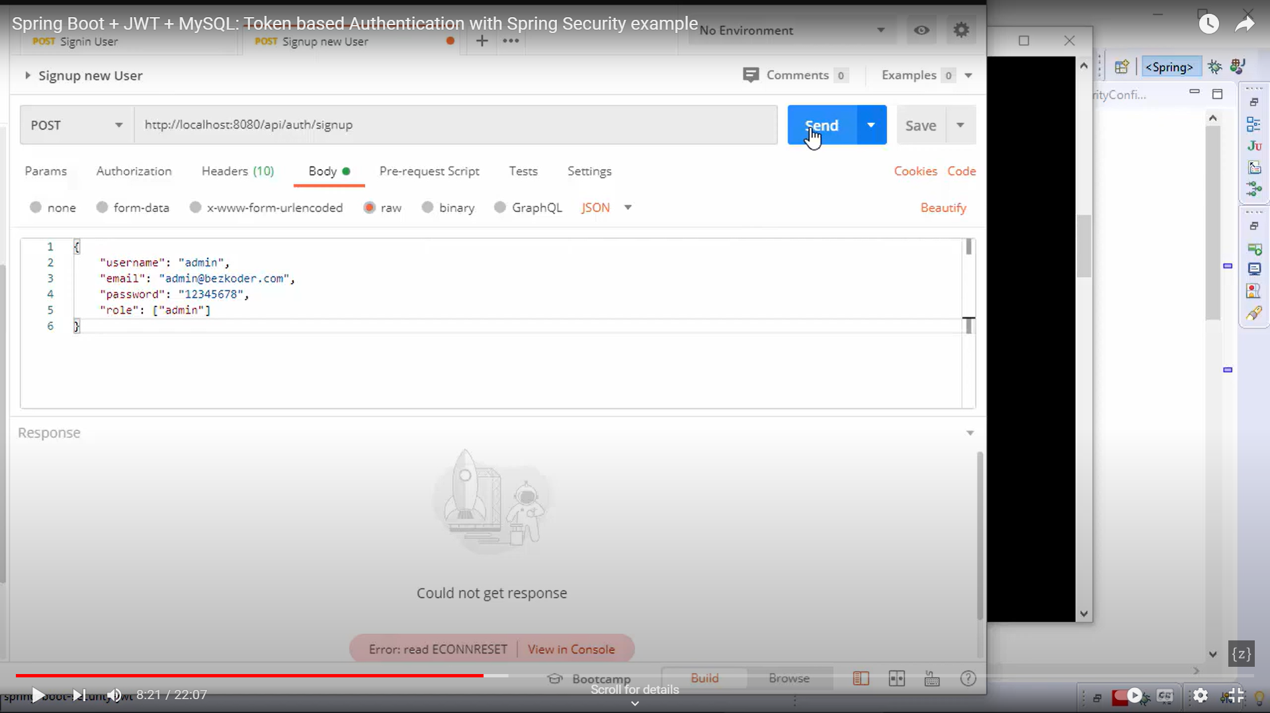

User sign in :

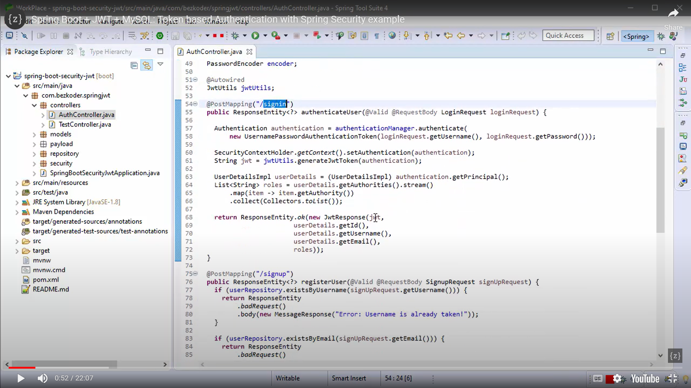

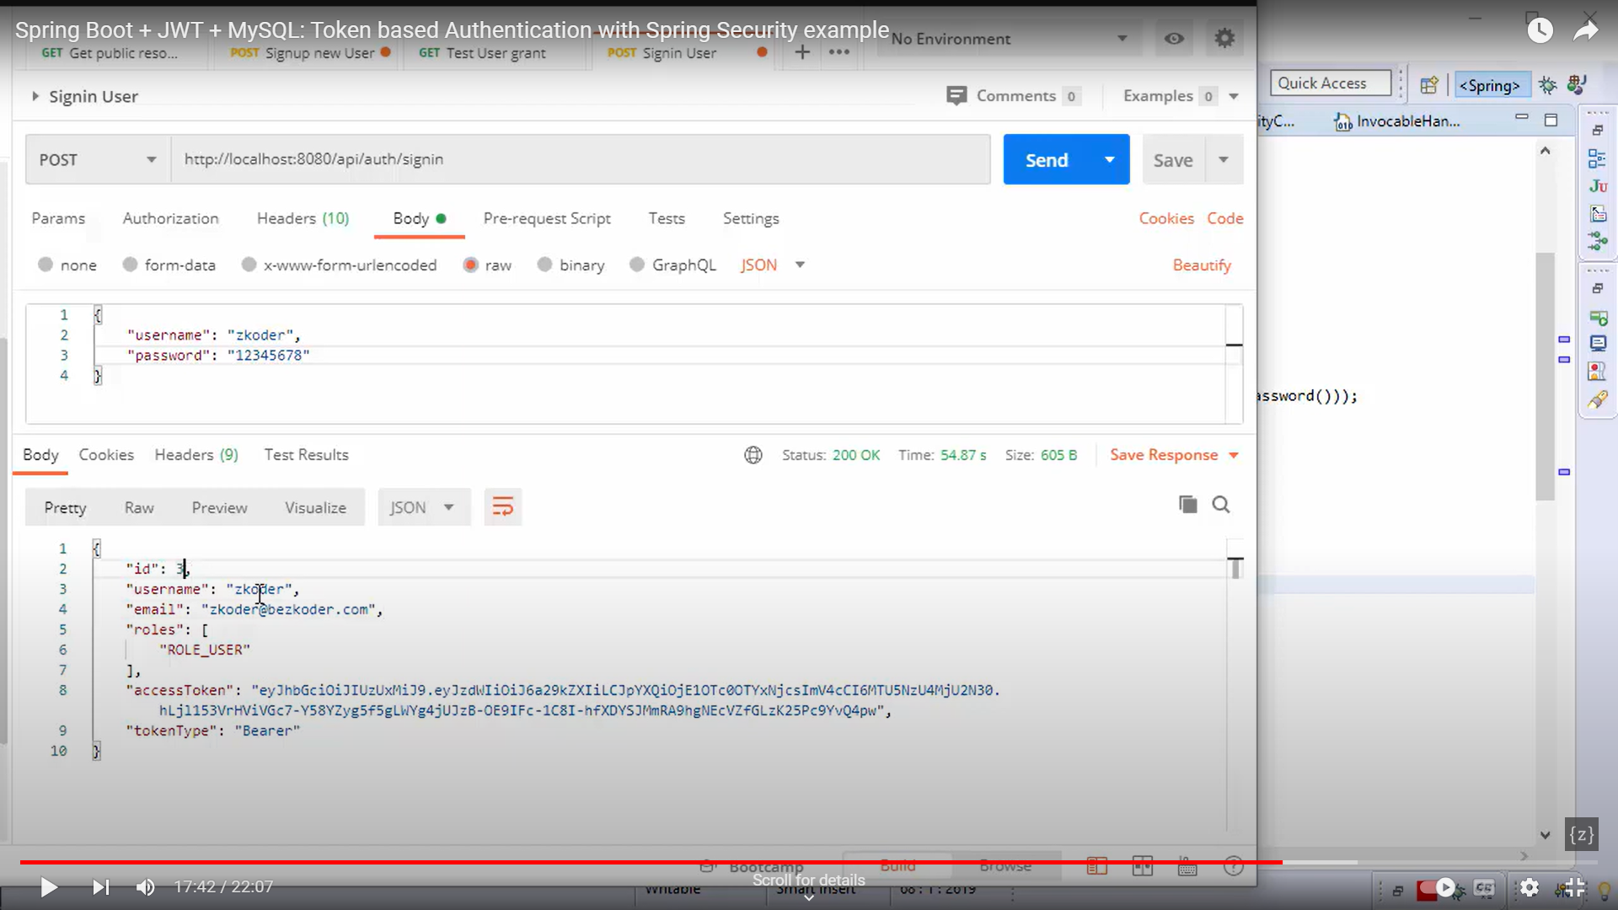

<https://medium.com/javarevisited/crack-your-backend-development-interview-must-know-questions-and-topics-7bf2cc066fdc>

2PC 2phase commit:

